9/1/2025

**API TESTING**

**REPORT**

* **INTRODUCTION:**

This report includes the process and outcomes of API testing performed using the Postman tool. The purpose of the testing was to validate the functionality of various HTTP methods (GET, POST, PUT, PATCH, DELETE) in an API.

* **OBJECTIVES:**
* To test the functionality of different HTTP request methods.
* To verify the expected responses and status codes for each request type.
* To ensure correct creation, retrieval, updating, and deletion of user data.
* To validate user registration and login functionalities.
* **TOOL USED:**
* **Postman**: A widely used API testing tool that allows users to send HTTP requests to RESTful APIs and view responses in a user-friendly interface.
* 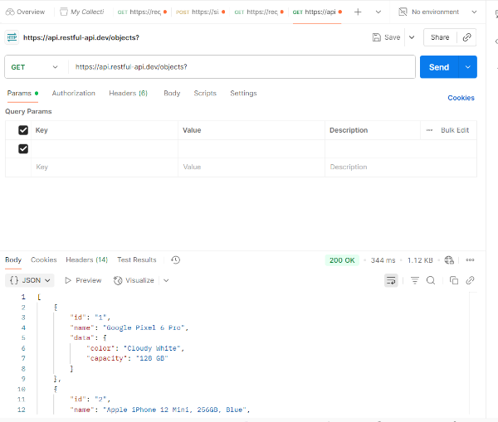**API TESTING PROCESS:**
* **GET Requests**

1. **List All Users**:

* A GET request was sent to the endpoint to retrieve all users.
* The API responded with a **200 OK** status code and returned a list of all users in the response body.

1. **Get Single User by ID**:
   * + A GET request was sent with a specific user ID as a query parameter.
     + The response included user details along with a **200 OK** status.

* **POST Request**

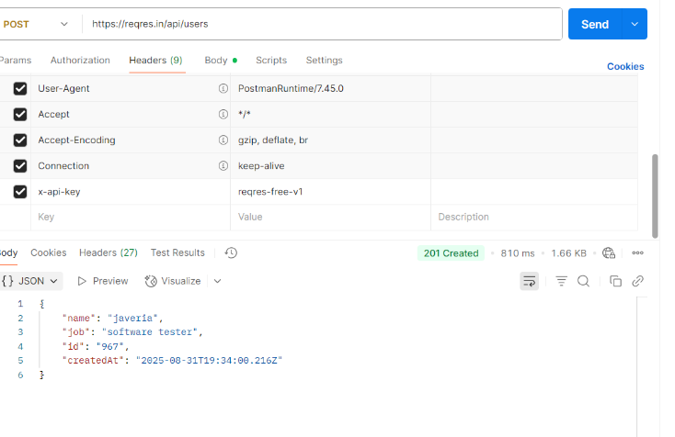**Create, Add, Register, and Login User:**

* POST requests were used for actions like creating, adding, registering, and logging in users.
* The required user data was included in the body of the request.
* The API responded with a 201 Created status, indicating successful creation or registration of the user.
* 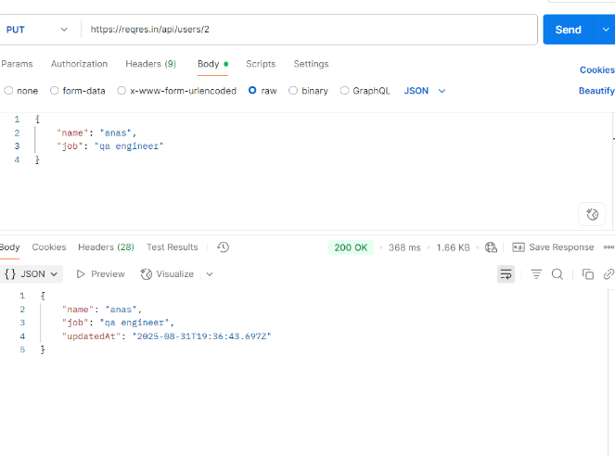**PUT and PATCH Requests**

**Update User Information:**

* Both PUT and PATCH methods were used to update user data such as name and job.
* PUT is typically used for full updates, while PATCH is used for partial updates.
* After sending these requests, the API responded with a 200 OK status code.
* The response body also included an updatedAt timestamp, confirming the data was successfully updated.
* 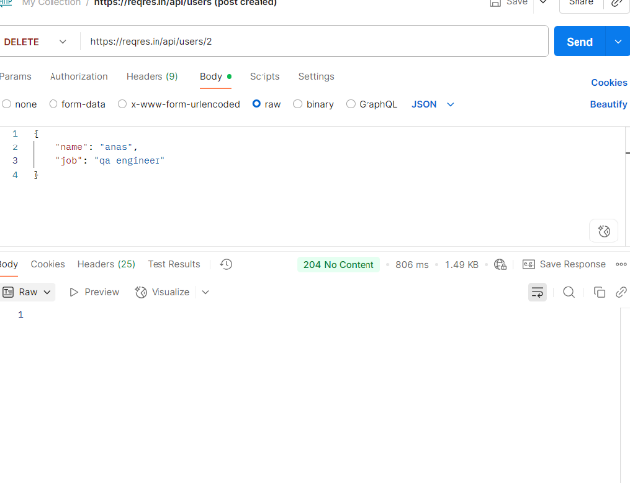**DELETE Request**

**Delete User Data:**

* A DELETE request was made to remove user data.
* The endpoint and necessary data were included in the request.
* The API returned a 204 No Content status, confirming successful deletion with no response body.
* **CONCLUSION**

The API testing conducted through Postman confirmed that the endpoints are functioning as expected. Each HTTP method produced the correct status code and response, demonstrating that the API can effectively handle user data operations, including retrieval, creation, updating, and deletion.